README
This README file, along with main.py and test_main.py, has been submitted both individually and as part of a compressed ZIP folder.
c. 1341 words
This is a README for the associated Python program (main.py) which aims to simulate an online retail store with some security checks, as specified in the design document from Unit 6.
This simulation program is accessed via a Command Line Interface (CLI) and demonstrates system behaviour under normal usage and under simulated cyberattacks – namely, brute force attacks, denial-of-service (DoS) attacks and injection attacks.
This system supports:
- User registration/authentication
- Role-Based Access Control (RBAC) (Lindemulder and Kosinski, n.d.)
- Session management
- Order placement
- Security attack simulations
This program also makes use of a secure_mode toggle to switch between enforced and disabled security controls, for the purposes of comparison, which is accessible in the main menu at any time; in a real scenario, this toggle would only be accessible if an admin user is logged in.

Requirements
- Python 3.x
The imported modules hashlib, time and uuid are part of Python’s standard library, so there’s no need to install any extra libraries to run.

Standard operation of the program
Upon downloading and navigating to the file, run the following in the terminal:
py ./main.py
The CLI menu will appear in the terminal:
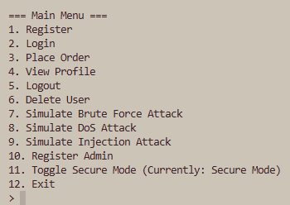
From here we can register a customer name and log in as a customer. Orders can be placed by inputting a string of items separated by a comma.
I have assumed grocery items for this list; in a real implementation there would be some check to see what items are available and for what prices. Similarly in a real implementation these Security Events should be logged in a separate console, and not the CLI.
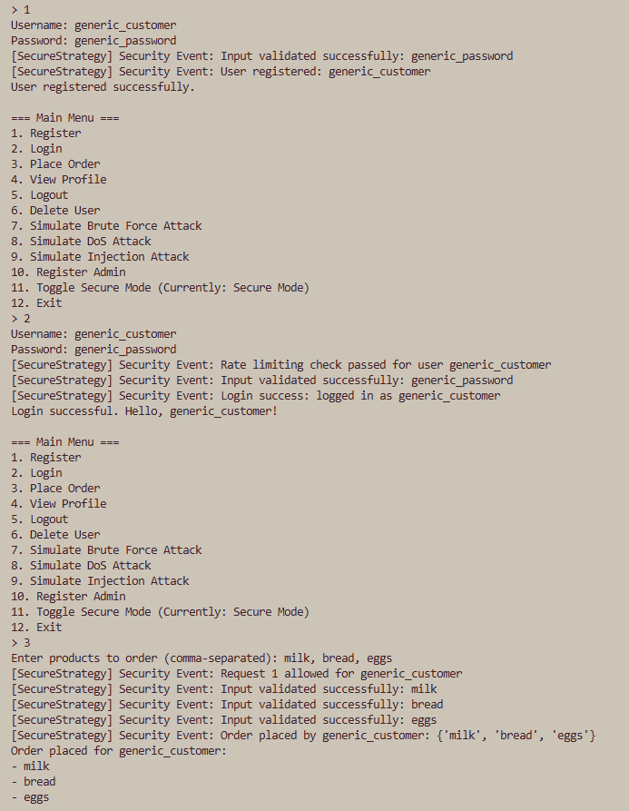

The user can also view their own profile, containing their username and role:
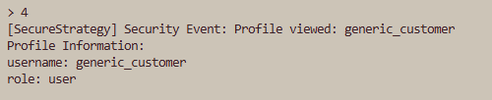
The user may delete their own profile.
If logged in as an administrator (a deliberately wrong password has been chosen for attack simulations later), one may delete any profile (as per RBAC):
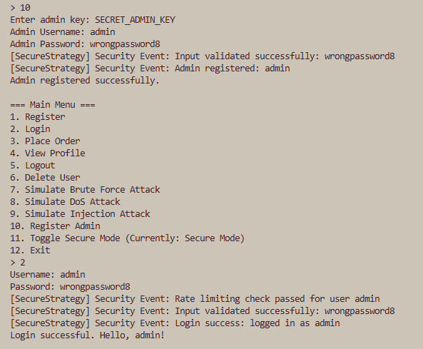
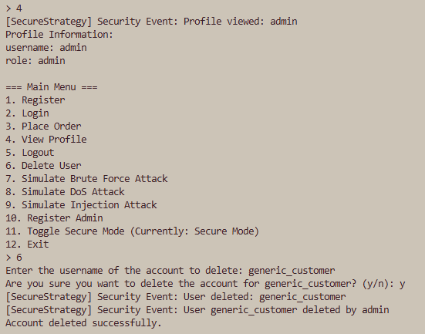

Security Mechanisms implemented:

Secure Mode ON – this is the default
- Password hashing using SHA-256 (via hashlib)
- Input validation (prevents injection attacks)
- Login rate limiting (brute force protection)
- Request rate limiting (DoS protection)
- Security event logging

Secure Mode OFF – only implemented for comparison’s sake
- No hashing (plaintext passwords)
- No input validation
- No rate limiting
- Minimal logging

Attack Simulations
To carry these simulations out, it is advised to remain logged in as an admin.

Brute Force Attack
A Brute Force attack is a trial-and-error method whereby a hacker bombards an input box, typically a password field, with many inputs in an attempt to gain access to an account (Fortinet, 2025). As the name suggests, and provided the desired password is sufficiently weak, this can mean a hacker can access an account with admin privileges merely by brute force.
The Brute Force attack simply forces a multitude of passwords for a given username (here, “admin”) to simulate a hacker trying a massive dictionary of password combinations in an attempt to gain unauthorised access. When secure_mode is on, the system should apply rate limiting and exponential backoff to restrict repeated attempts. (This does affect trying to log back into the admin user – exiting the program and re-registering is advised.)
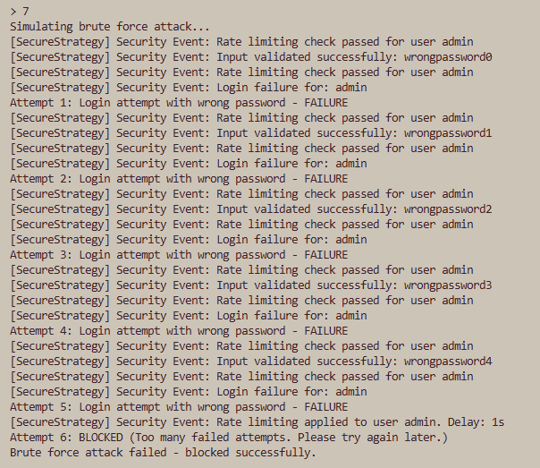
No such protections exist when secure_mode is off, unless the password was generated while in secure_mode, because the password is only stored as a hash in that case. The following is when the password is generated in secure mode, but the Brute Force simulation is conducted with it deactivated:
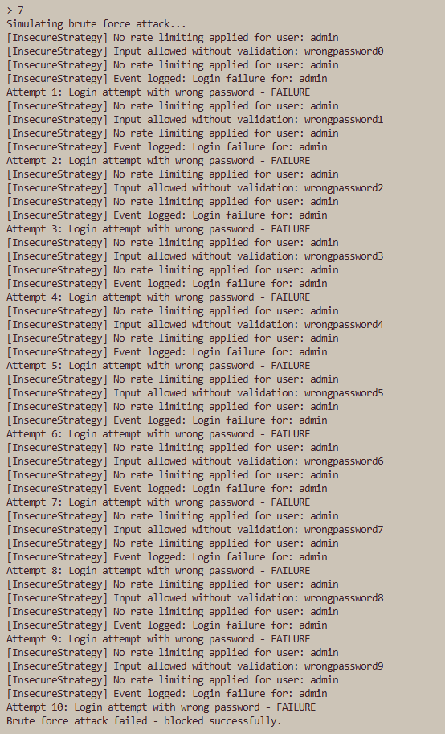
And here is what happens if secure_mode has been off the whole time, from password generation to the attack itself, and if the password actually does match one of the brute-forced ones (truncated for legibility):
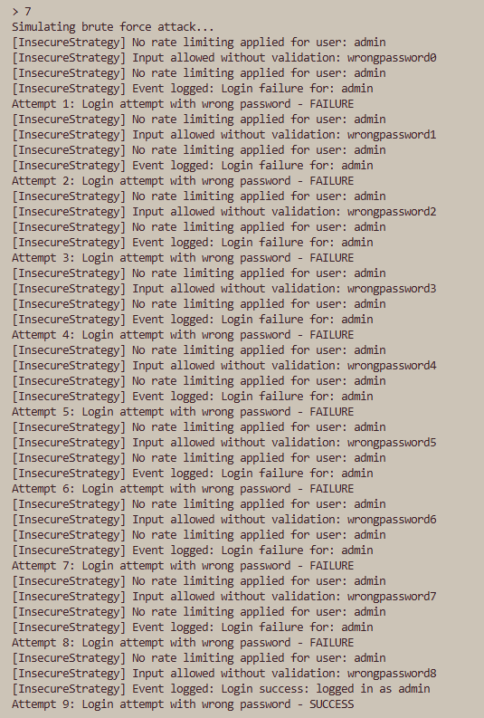

Denial of Service (DoS) Attack
A DoS attack is an attempt to overwhelm a program or network with a lot of traffic to drastically slow it down (Cloudflare, n.d.). This can be a hacker’s goal in itself, since the disruption can have knock-on effects – here for example, a slow website results in fewer customers and fewer orders, ultimately resulting in less revenue.
This attack simulates a high volume of rapid requests by repeatedly placing orders in quick succession with minimal wait time between each order, which is a good indication of the orders being programmatically sent (as opposed to being entered by a human). Though in practice a hacker would try and force several hundreds of requests at once into the program, this simulation only uses 20 orders for simplicity’s sake.
When secure_mode is enabled, a rate limit is triggered after 10 consecutive orders, blocking subsequent orders. When disabled, all 20 orders get passed into the program.
Here’s secure_mode ON:
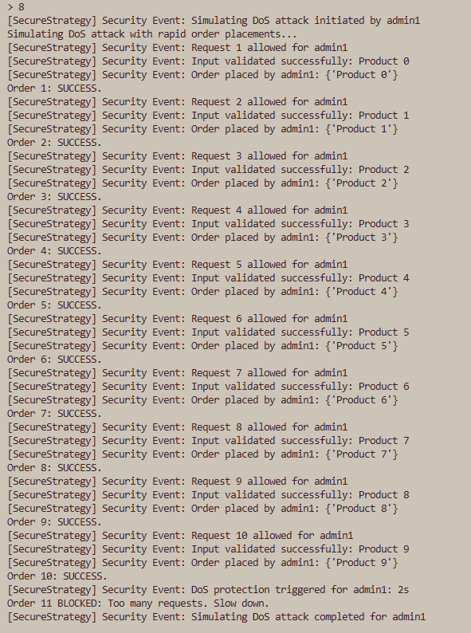
And here secure_mode is turned OFF:
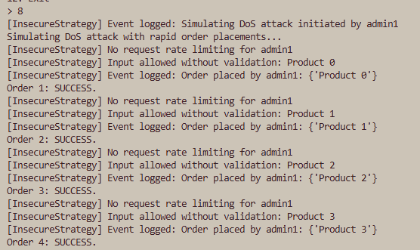
(This continues in this fashion without error until…)
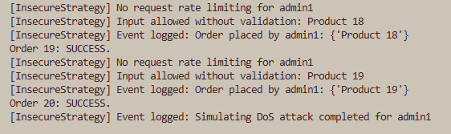

Injection attack
In a program that has fields into which users can enter data, an attacker may take advantage of these fields to send malicious code, essentially injecting code into the program (Lenaerts-Bergmans, 2024); since our program contains such fields, it is important to sanitise and otherwise check these input fields.
The injection simulation here involves a crafted string resembling a SQL payload which gets passed into the program as user input. In secure_mode, input validation detects and rejects potentially dangerous patterns, thus mitigating against such an injection.

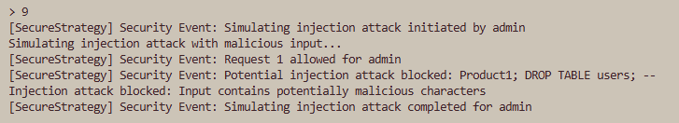 (In the insecure mode, no such validation exists and the input is accepted – this demonstrates the risk of a lack of filters.)
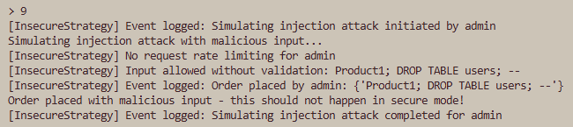

Automatic Testing
Some automatic testing was conducted via Pytest, specifically to validate the security mechanisms. Ensure Pytest is installed (pip install pytest, then run pytest to confirm). Then in the terminal run pytest in the same place as the folder containing the ./main.py and ./test_main.py files.
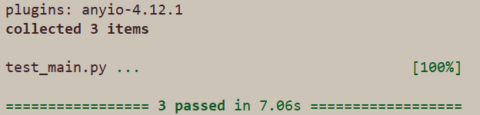

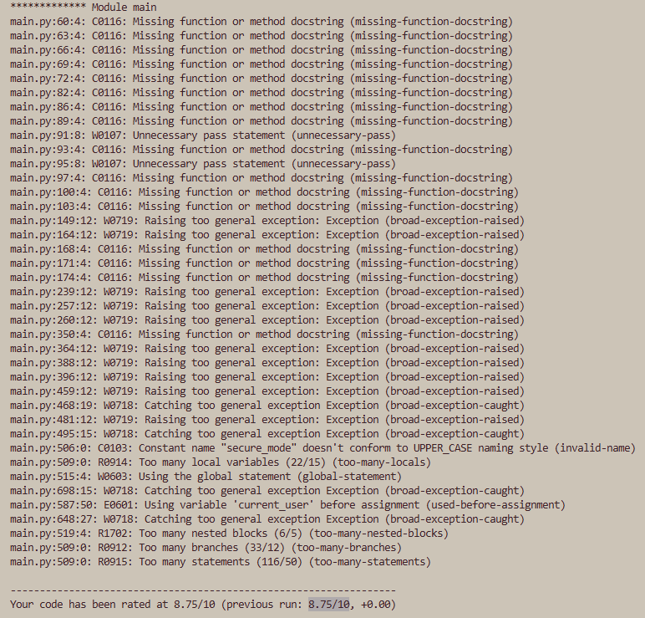
Manual Testing
As explored above, the CLI allows for direct testing of user authentication, RBAC and attack simulations, the latter exploring various types thereof.
This project has also used Pylint (reporting an 8.75/10) and Flake8 to support code quality and legibility as per the PEP-8 style guide for Python (von Rossum, 2001). Certain reported warnings, however, reflect intentional architectural choices rather than full violations of the guidelines.

Missing Docstrings
Pylint flags several methods as missing docstrings. This is deliberate in this document in certain cases:
- Many methods, such as “delete_user”, “login” and “place_order”, are self-explanatory and follow standard CRUD semantics (Codecademy, n.d.).
- Several functions exist as overrides (such as those in SecurityStrategy), and docstrings would create unnecessary duplicate documentation.

Broad Exceptions
Warnings related to Exception usage are expected due to this being a controlled simulation environment.
- Exceptions are used to simulate security failure states such as authentication failures.
- The focus of this project is on emulating the behaviour of security mechanisms, so being pedantic on exceptions is oftentimes unnecessary.

CLI Complexity Warnings
This comes from intentionally building the user experience in a single interactive control loop. Complexity metrics such as branches and nested blocks reflect the breadth of simulated behaviours; in an actual production system, this logic would be split into separate handlers to minimise complexity.

Character Limit
While Pylint defaults to a maximum line length of 100, Flake8 adheres to the 79-character recommendation by PEP 8 to minimise the wrapping from code editors disrupting the presentation of the code (hence several E501 linter errors). This however appears to be a “hangover from developing in a Unix terminal window” (The GDS Way, n.d.); most IDEs can handle greater line lengths, and most monitors have a high enough resolution to cleanly display far more characters in a single line. While The GDS Way prefers 120 characters as its limit, I’ve settled on Pylint’s 100-character limit default.

Possible improvements in future
- Password salting (Hughes, 2024)
In the secure mode, passwords are already hashed, i.e. transformed into a fixed-size string of randomised characters. Ideally it should also be salted, i.e. this hash needs extra random data (based on the hash) to further obfuscate the password.
- A real API integration e.g. via Stripe
For this project, any data that is stored is kept local, though an application programming interface (API) would enable the program to not have to store information like card details and other sensitive information, resulting in a smaller attack surface.

References
Cloudflare (n.d.) What is a denial-of-service (DoS) attack? Available at: https://www.cloudflare.com/en-gb/learning/ddos/glossary/denial-of-service/ [Accessed: 13th April 2026]
Codecademy (n.d.) What is CRUD? Explained. Available at: https://www.codecademy.com/article/what-is-crud-explained [Accessed: 13th April 2026]
Fortinet (2025) What Is A Brute Force Attack? Available at: https://www.fortinet.com/uk/resources/cyberglossary/brute-force-attack [Accessed: 13th April 2026]
Lenaerts-Bergmans, B (2024) What is an Injection Attack? Available at: https://www.crowdstrike.com/en-us/cybersecurity-101/cyberattacks/injection-attack/ [Accessed: 13th April 2026]
Lindemulder, G, Kosinski, M (n. d.) What is role-based access control (RBAC)? Available at: https://www.ibm.com/think/topics/rbac [Accessed: 12th April 2026]
Hughes, A (2024) Encryption vs. Hashing vs. Salting - What's the Difference? Available at: https://www.pingidentity.com/en/resources/blog/post/encryption-vs-hashing-vs-salting.html [Accessed: 13th April 2026]
von Rossum, G (2001) PEP-8 - Style Guide for Python Code. Available at: https://peps.python.org/pep-0008 [Accessed: 13th April 2026]
The GDS Way (n.d.) Python style guide. Available at: https://gds-way.digital.cabinet-office.gov.uk/manuals/programming-languages/python/python.html [Accessed: 13th April 2026]

